Eyeconic - Glasses Shop Management System

Use-Case Specification: Edit Glasses

Version 1.0

Revision History

|  |  |  |  |
| --- | --- | --- | --- |
| **Date** | **Version** | **Description** | **Author** |
| 05/11/2019 | 1.0 | Start creating use case | Đỗ Nguyễn Hoàng Ân |
|  |  |  |  |
|  |  |  |  |
|  |  |  |  |

Table of Contents

1. Edit Glasses 4

1.1 Brief Description 4

2. Flow of Events 4

2.1 Basic Flow 4

2.2 Exception 4

2.2.1 Edit glasses 4

2.2.2 Fill in the glasses’ information 5

3. Special Requirements 5

4. Preconditions 5

4.1 Admin must be logged in 5

5. Postconditions 5

6. Extension Points 5

Use-Case Specification: Edit Glasses

# Edit Glasses

## Brief Description

This use case defines the step of editing existing glasses from the database.

Glasses are edited by the admin.

# Flow of Events

## Basic Flow

The system administrator selects the glasses data to edit. The administrator changes the needed information. The system displays the updated management parameter value and logs the change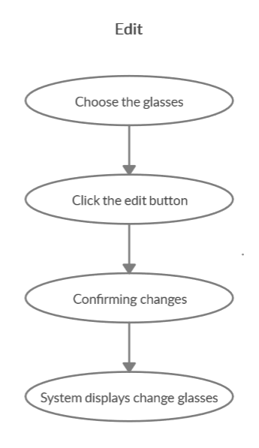

***Basic flow of Editing Glasses***

Step 1: Choose the glasses you want to edit

Step 2: Click edit button

A modal view shows up

Edit the change needed

Step 3: Confirming editing the glasses by clicking the “Save” button.

Step 4: Successful information changed glasses are displayed on the screen

## 2.2 Exception

### 2.2.1 Edit glasses

The add button cannot be clicked or isn’t appeared on the screen

### 2.2.2 Fill in the glasses’ information

Invalid information.

2.2.3 Confirming editing the glasses

The “Save” button is clicked but the new information of the glasses is not changed.

2.2.4 System displays added glasses

The edited glasses’ information is not displayed correctly.

# Special Requirements

No Special Requirements

# Preconditions

## 4.1 Admin must be logged in

User must already login as the administrator of the website

# Postconditions

Glasses information is changed and can be purchased by customers

# Extension Points

Administrator checks the website and the system to ensure that the edited information of the glasses is correct.